**Enemies Among Us**

**by Bettina Petersen**

Article about invasive species. Article about invasive species. Article about invasive species. Article about invasive species. Article about invasive species. Article about invasive species. Article about invasive species. Article about invasive species. Article about invasive species. Article about invasive species. Article about invasive species. Article about invasive species. Article about invasive species. Article about invasive species. Article about invasive species. Article about invasive species. Article about invasive species. Article about invasive species.

Article about invasive species. Article about invasive species. Article about invasive species. Article about invasive species. Article about invasive species. Article about invasive species. Article about invasive species. Article about invasive species. Article about invasive species. Article about invasive species. Article about invasive species. Article about invasive species. Article about invasive species. Article about invasive species. Article about invasive species.

Article about invasive species. Article about invasive species. Article about invasive species. Article about invasive species. Article about

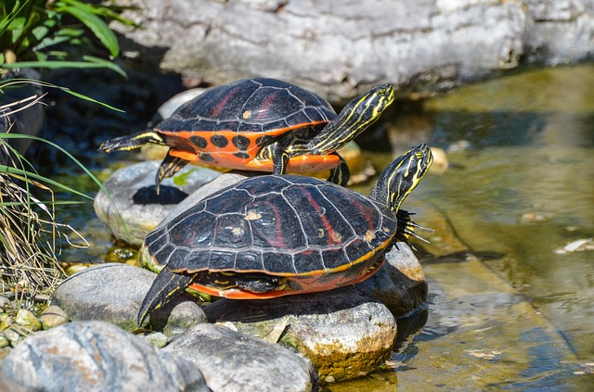

Article about invasive species. Article about invasive species. Article about invasive species. Article about invasive species. Article about invasive species. Article about invasive species. Article about invasive species. Article about invasive species. Article about invasive species.

Article about invasive species. Article about invasive species. Article about invasive species. Article about invasive species. Article about invasive species. Article about invasive species. Article about invasive species. Article about invasive species. Article about invasive species.

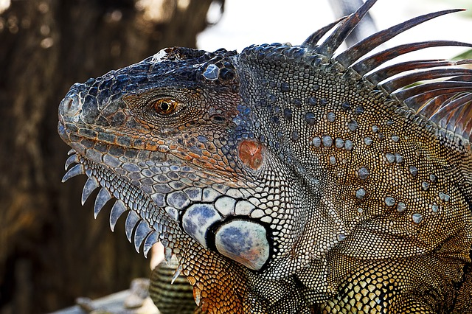

Article about invasive species. Article about invasive species. Article about invasive species. Article about invasive species. Article about invasive species. Article about invasive species. Article about invasive species. Article about invasive species. Article about invasive species.

Article about invasive species. Article about invasive species. Article about invasive species. Article about invasive species. Article about invasive species. Article about invasive species. Article about invasive species. Article about

invasive species. Article about invasive species. Article about invasive species. Article about invasive species. Article about invasive species.

Article about invasive species. Article about invasive species. Article about invasive species. Article about invasive species. Article about invasive species. Article about invasive species. Article about invasive species. Article about invasive species. Article about invasive species.

Article about invasive species. Article about invasive species. Article about invasive species.

Article about invasive species. Article about invasive species. Article about invasive species.